***Lab 10 Task (Database Systems lab)***

Name = Poorab Gangwani

Class = 4B1

Roll-Number = CS191092

**Create an index on any column of the students table.**

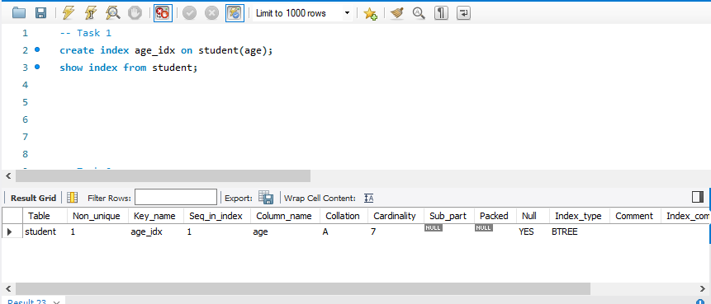

**Create a UNIQUE index on the department names in the departments table.**

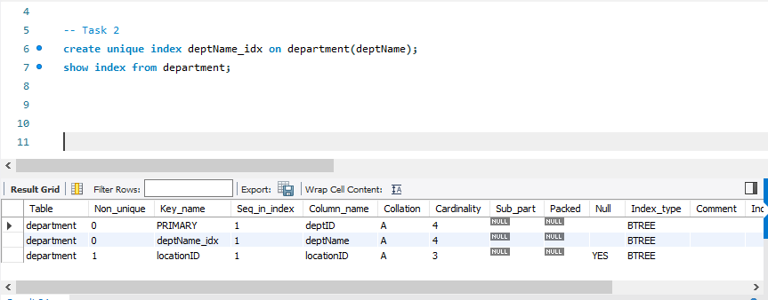

**Create a composite UNIQUE index on the names of all the employees.**

